Task 1: Clone the <https://github.com/udmis/freelancer> to your computer and use Chrome DevTools to study the files and answer the following questions (just type your answers in this file):

1. Specify the file and line number of the CSS rule that makes the avatar shown as a circle and explain how this rule works. What’s the size of the avatar? How to make it smaller?

The file is freelancer.css, the line number of the CSS rule is 168

Size: 300\*300 (sized the picture to 300\*300 pixels)

How to make it smaller:

I can just add a line of code at line 171 saying “width:200px;”  


1. Specify the file and line number of the CSS rule that implements the following part and explain how this rule works. Explain how the star is in the middle and how to move that to the right of the horizontal line?  
   

how the star is in the middle: text-align: center from freelancer.css:39

how to move that to the right of the horizontal line: change the “center” to “right”

1. Explain how you can make the portfolio part to show as follows on iPad, copy and paste the code.  
   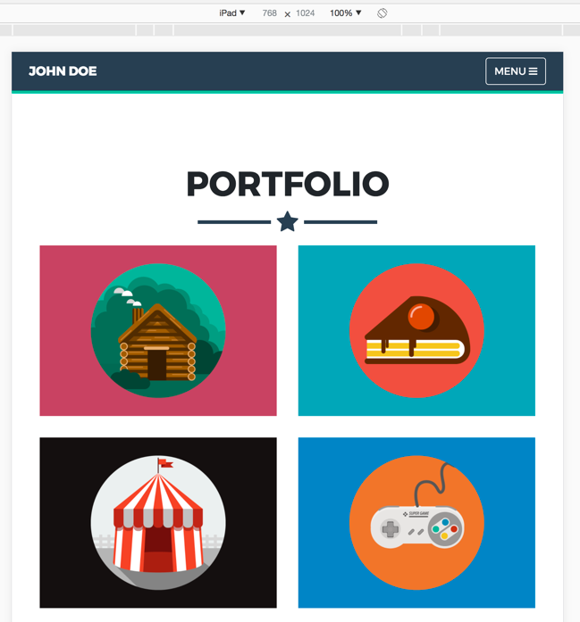

Since it uses bootstrap grid system to display those portfolio, if we want to display it as a 3 rows 2 columns format, we can simply change the <div class="col-sm-4 portfolio-item"> to <div class="col-sm-6 portfolio-item">.

1. Does the footer use Bootstrap? If yes, how? Such as how many columns defined? What css classes used and what do those classes mean?  
   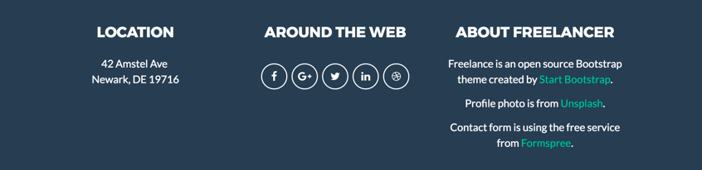

Yes. The footer uses bootstrap. 3 columns are defined.

Classes:

1. footer-above—including the style for the upper part of footer—the shown contents in the picture

2.footer-below-including the style for the lower part of footer—doesn’t show in the pic. Including “copyright@ John Doe 2017”

3. footer-col—the columns of the footer, dividing the footer into 3 parts including location, around the web and about freelancer

1. When hovering over the social media icons in the footer, the color of the icon changed. Explain how that effect is implemented (use file and line number if necessary).  
   

File and line: freelancer line21

The code is:

a:hover {

color: #18BC9C;

outline: none; }

which means that when you hover your mouse on that icon, the color of it will become #18BC9C and there will be no outline anymore

Task 2: In this task, you need to revise the html page you created in Assignment “HTML Basics” by adding a css file. You can name your html and css files anything you want, but I suggest using index.html and about-me.css. You need to do the followings:

1. Use bootstrap and fontawesome using CDN
2. Change the avatar image to your image of choice. Its size should be 200px all around. It should show as a circle.
3. Create a portfolio section to show 8 of your images of your choice (you should put all images in a sub-folder “img”). The 8 images should be show up in 2 rows with 4 in each row on desktop size(m) screen and change to 4 rows with 2 image per row on tablet size screen.
4. Create a footer section and add your social media icon and links using fontawesome, you can choose any three or more icons from fontawesome website.
5. Create a new repo called “about-me” and push all your files to the repo
6. Upload the updated version of this website to AWS S3

For task 2, you need to submit the url of your repo created in e) and the URL for your website created in f).

e) https://github.com/oliviapy960825/about-me

f) <https://s3.amazonaws.com/misy350-assignment1/about-me/freelancer.html>